Cervical cancer detection system

Project Objective
To develop an AI/ML-based system that analyzes cervical cell images and classifies them into:
- Normal
- Abnormal

1. Dataset
- Dataset: Herlev Pap-Smear Dataset
- Original files found: 1834
- .BMP → actual cell images ✅
- -d.bmp → segmentation/mask images ❌
- Used only actual cell images → 917 images

2. Classification
Converted 7 classes into 2 classes:
- Normal: 242 images
- Abnormal: 675 images
Normal → 0
Abnormal → 1

3. Dataset Split
Training → 641
Validation → 138
Testing → 138
Total → 917
Split ratio:
70% Train
15% Validation
15% Test

4. Preprocessing
- Resize images → 224 × 224
- Convert → RGB
- Convert image → Tensor
- Normalize images

5. PyTorch
Installed and tested:
- PyTorch ✅
- Torchvision ✅
- Scikit-learn ✅
- Matplotlib ✅
DataLoader tested successfully:
Batch = 32 images
Shape = [32, 3, 224, 224]

6. Important Issue
Dataset is imbalanced:
Normal = 242
Abnormal = 675
So we should not depend only on accuracy.

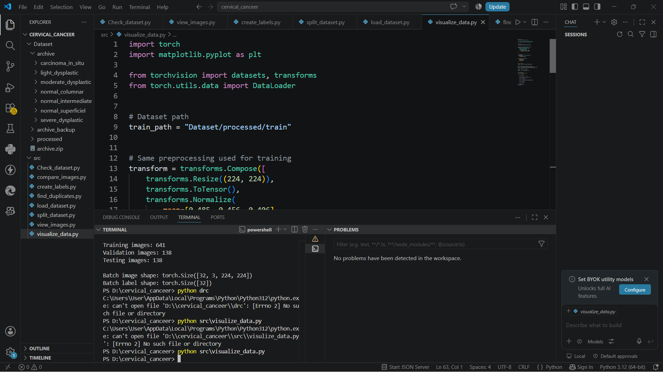

Clinical baseline model: Logistic Regression
Cross-validation: 5-fold stratified
Average accuracy: 84.04%
Average cancer recall: 33.33%
Average F1-score: 8.01%
Observation: Severe class imbalance and limited cancer-positive samples make the clinical dataset unsuitable as a standalone cancer detector.

Image model: ResNet18
Test images: 138
Accuracy: 86.96%
Abnormal precision: 86%
Abnormal recall: 99%
Abnormal F1: 92%
Observation: The model detected 101/102 abnormal test images but incorrectly classified 17 normal images as abnormal.
Single-image prediction: Completed ✅
Model successfully accepts a .BMP image and predicts Normal or Abnormal with probability/confidence.
Example: Abnormal image → Abnormal prediction, 84.21% confidence.
single-image testing:
Abnormal test image → correctly predicted abnormal (84.21%).
Normal test image → predicted abnormal (78.40%), showing a false positive.
Observation: Model has high abnormal recall but produces false positives on some normal images.

Compare with original
Model | Best Validation Accuracy
Original ResNet18 | 92.75%
Balanced ResNet18 | 94.20% ✅

